Coping file and folder from local system to Ec2 instances
1 launch instance
2 Convert .pem file to .ppk file using puttygen
3 Create a file in local system name file
4 Open CMD and go to the location of file
C:\Users\Cjp\Documents
Using cd command
Cd /
Cd Users
Cd Cjp
Cd Documents
Be inside directory and run this following command
This command will copy into instance
1 pscp -i demo.ppk file.txt ubuntu@publicip:/home/ubuntu
// if the file is named as file then we need use as file.txt
// if the file is named as file.txt then we need use as file.txt.txt

This commad will copy whole directory into instance
2 pscp -i demo.ppk -r foldername ubuntu@publicip:/home/ubuntu

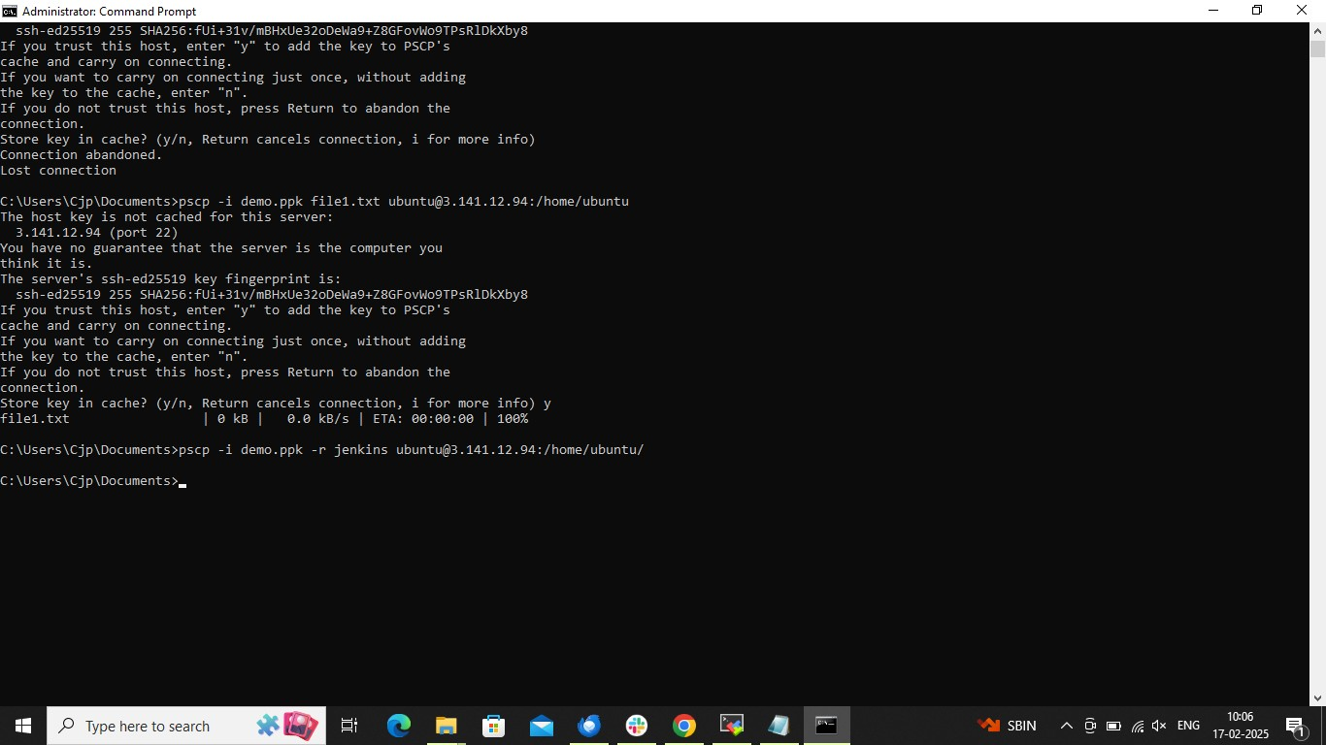

To copy files from instance to instance

Launch two instances make it up and running
Open .pem file and copy the key
SSH into any instance
1 Create a any file example test
2 Create key.pem and paste the key of .pem file
3 chmod 400 key.pem or chmod +x key.pem
Now run the following command

Scp -i key.pem test ubuntu@public ip of another instance:/home/ubuntu
